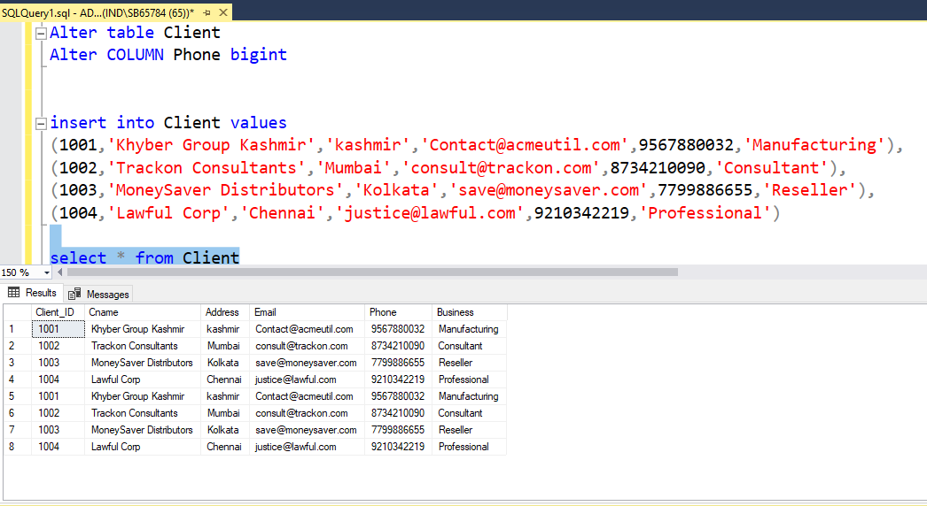

Table Client

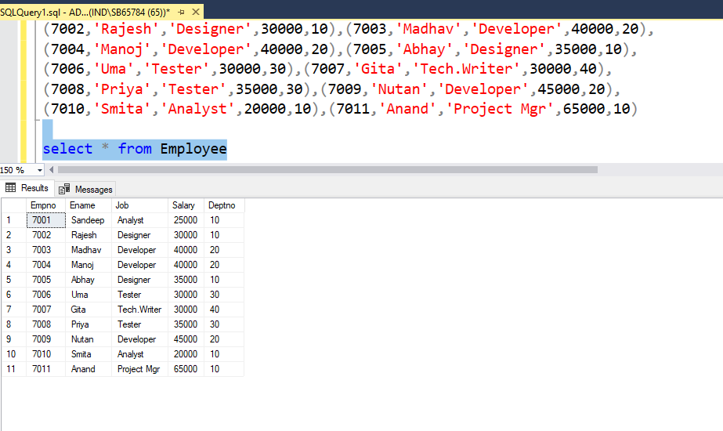

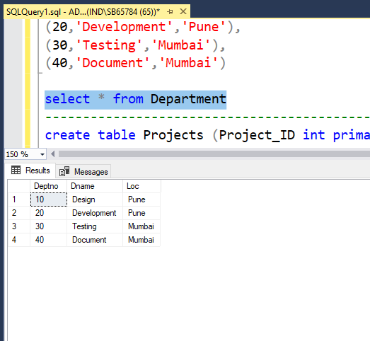

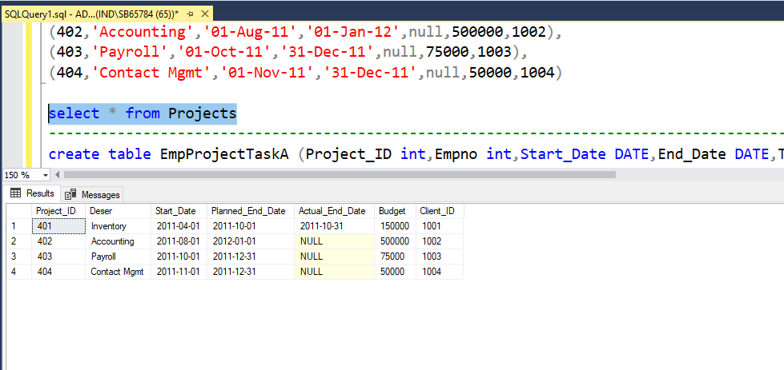

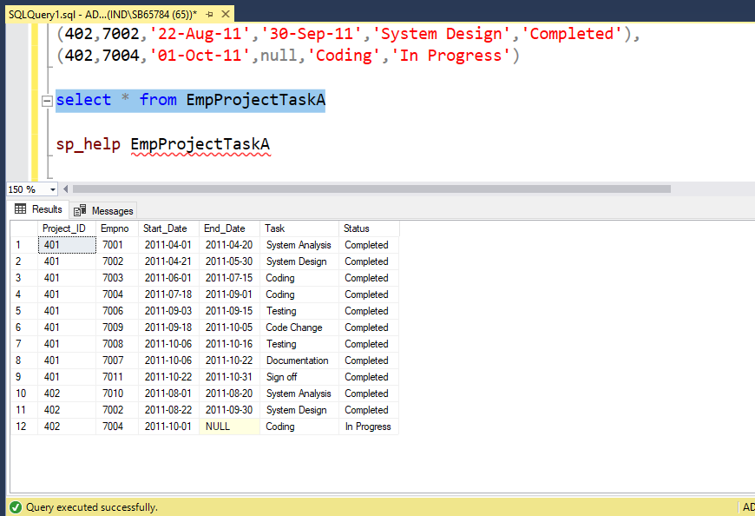

TEXT DOCUMENT For QUERIES

create database SpecialAssignment

use SpecialAssignment

create table Client(Client_ID int,Cname varchar(40) not null,Address varchar(30),Email varchar(30),Phone int,Business varchar(20))

--modifying DataType in a column in a table named client

Alter table Client

Alter COLUMN Phone bigint

insert into Client values

(1001,'Khyber Group Kashmir','kashmir','Contact@acmeutil.com',9567880032,'Manufacturing'),

(1002,'Trackon Consultants','Mumbai','consult@trackon.com',8734210090,'Consultant'),

(1003,'MoneySaver Distributors','Kolkata','save@moneysaver.com',7799886655,'Reseller'),

(1004,'Lawful Corp','Chennai','justice@lawful.com',9210342219,'Professional')

select * from Client

create table Employee (Empno int primary key,Ename varchar(20) not null,Job varchar(15),Salary float,Deptno int)

insert into Employee values(7001,'Sandeep','Analyst',25000,10),

(7002,'Rajesh','Designer',30000,10),(7003,'Madhav','Developer',40000,20),

(7004,'Manoj','Developer',40000,20),(7005,'Abhay','Designer',35000,10),

(7006,'Uma','Tester',30000,30),(7007,'Gita','Tech.Writer',30000,40),

(7008,'Priya','Tester',35000,30),(7009,'Nutan','Developer',45000,20),

(7010,'Smita','Analyst',20000,10),(7011,'Anand','Project Mgr',65000,10)

select * from Employee

-----------------------------------------------------------------------------------------------------------------------------------------------------------------------------------------

create table Department (Deptno int primary key,Dname varchar(15) not null,Loc varchar(20))

insert into Department values

(10,'Design','Pune'),

(20,'Development','Pune'),

(30,'Testing','Mumbai'),

(40,'Document','Mumbai')

select * from Department

----------------------------------------------------------------------------------------------------------------------------------------------------------------

create table Projects (Project_ID int primary key,Deser varchar(30) not null,Start_Date DATE,Planned_End_Date DATE,Actual_End_Date DATE,Budget int,Client_ID int)

insert into Projects values(401,'Inventory','01-Apr-11','01-Oct-11','31-Oct-11',150000,1001),

(402,'Accounting','01-Aug-11','01-Jan-12',null,500000,1002),

(403,'Payroll','01-Oct-11','31-Dec-11',null,75000,1003),

(404,'Contact Mgmt','01-Nov-11','31-Dec-11',null,50000,1004)

select * from Projects

----------------------------------------------------------------------------------------------------------------------------------------------------------------

create table EmpProjectTaskA (Project_ID int,Empno int,Start_Date DATE,End_Date DATE,Task varchar(25) not null,Status varchar(15) not null)

insert into EmpProjectTaskA values(401,7001,'01-Apr-11','20-Apr-11','System Analysis','Completed'),

(401,7002,'21-Apr-11','30-May-11','System Design','Completed'),

(401,7003,'01-Jun-11','15-Jul-11','Coding','Completed'),

(401,7004,'18-Jul-11','01-Sep-11','Coding','Completed'),

(401,7006,'03-Sep-11','15-Sep-11','Testing','Completed'),

(401,7009,'18-Sep-11','05-Oct-11','Code Change','Completed'),

(401,7008,'06-Oct-11','16-Oct-11','Testing','Completed'),

(401,7007,'06-Oct-11','22-Oct-11','Documentation','Completed'),

(401,7011,'22-Oct-11','31-Oct-11','Sign off','Completed'),

(402,7010,'01-Aug-11','20-Aug-11','System Analysis','Completed'),

(402,7002,'22-Aug-11','30-Sep-11','System Design','Completed'),

(402,7004,'01-Oct-11',null,'Coding','In Progress')

select * from EmpProjectTaskA

sp_help EmpProjectTaskA